JAWABAN UTS SBD Teori

1. System file adalah program mengelola file os, sedangkan data base dari basis data.

Perbedaan dari keduanya adalah system file membantu menyimpan data sedangkan database mengelola database.

System file diisntal dengan os, management sederhana, tetapi memiliki keamanan rendah. Data tidak sinkron.

Sementara database program menyimpan dan memanajemen dan mengambil data di dalam database, memiliki sinkronisasi dan tingkan keamanan keamanan dan kemudahan mengakses dan mengelola data dibandingkan system file.

1. Customer.Nm_Cust = “Muntu”

Jml = 0

find any Customer using Nm_Cust

While DB_status = 0 do

begin

get Customer

Find first Plat within CustomerPlat

While DB_status = 0 do

begin

Find owner within MobilPlat

while DB_status = 0 do

begin

Find first PartRusak within MobilPartRusak

While DB_status = 0 do

Begin

Find owner within PartPartRusak

While DB_status = 0 do

begin

Find first Harga within PartHarga

get Harga

Jml = Jml + Harga

end

find next PartRusak

end

end

find next Plat

End

print (Customer.Nm_Cust, Jml)

end

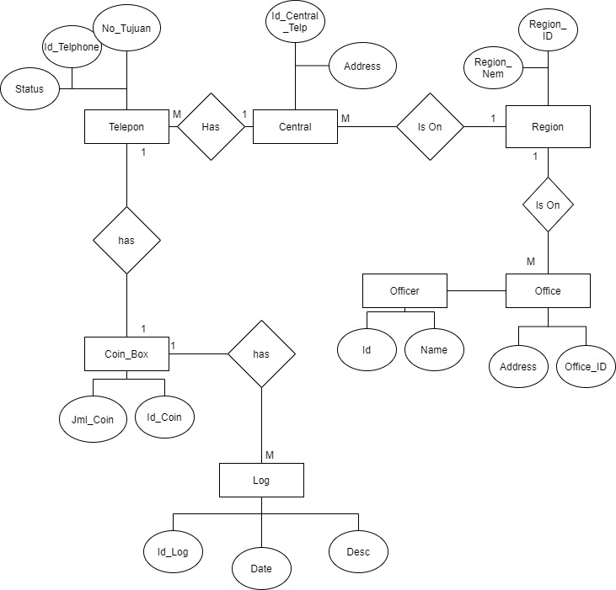

1. A. ISAM statis, efektif digunakan jika file sering diperbaharui, dan ISAM adalah struktur penyimanan terintegrasi.

Sementara B+Tree bersifar dinamis, dapat diatur perubahannya, mendukung query persamaan dan rentang, menudukung pencarian dalam sebuah rangem dan di B+Tree dapat menangani insertion dan deletion.

B1. 10000/20 = 500

B2. B+Tree (M-Ary) dengan M=10 (1blok = 10 record)

|  |  |  |  |  |  |  |  |  |  |  |  |  |  |  |  |  |  |  |
| --- | --- | --- | --- | --- | --- | --- | --- | --- | --- | --- | --- | --- | --- | --- | --- | --- | --- | --- |
| A | 1001 | B | 2001 | C | 3001 | D | 4001 | E | 5001 | F | 6001 | G | 7001 | H | 8001 | I | 9001 | J |

Level 1

|  |  |  |  |  |  |  |  |  |  |  |  |  |  |  |  |  |  |  |
| --- | --- | --- | --- | --- | --- | --- | --- | --- | --- | --- | --- | --- | --- | --- | --- | --- | --- | --- |
| a | 1101 | b | 1201 | c | 1301 | d | 1401 | e | 1501 | f | 1601 | g | 1701 | h | 1801 | i | 1901 | J |

Level 2 =

|  |  |  |  |  |  |  |  |  |  |  |  |  |  |  |  |  |  |  |
| --- | --- | --- | --- | --- | --- | --- | --- | --- | --- | --- | --- | --- | --- | --- | --- | --- | --- | --- |
| 1 | 1311 | 2 | 1321 | 3 | 1331 | 4 | 1341 | 5 | 1351 | 6 | 1361 | 7 | 1371 | 8 | 1381 | 9 | 1391 | 10 |

Level 3 (b+tree) =

|  |  |  |  |  |  |  |  |  |  |  |  |  |  |  |  |  |  |  |
| --- | --- | --- | --- | --- | --- | --- | --- | --- | --- | --- | --- | --- | --- | --- | --- | --- | --- | --- |
|  | 1301 |  | 1302 |  | 1303 |  | 1304 |  | 1305 |  | 1306 |  | 1307 |  | 1308 |  | 1309 |  |

1. A. (π a.Rp_Total (σ a.Rp_Total < b.Rp_Total (ρ a (Order) ⨯ ρ b (Order))) ∩π a.Rp_Total (σ a.Rp_Total > b.Rp_Total (ρ a (Order) ⨯ ρ b (Order)))

B. π Barang.Kd_Barang (Barang ⨝ (Place ⨝ (σ Kec.Nm_Kec='Merdeka' ∨ Kec.Nm_Kec='StBudi' (Kec ⨝ Gudang))))

C. Select Kd_Barang from Barang where Kd_Barang In (Select Kd_Barang from Place Where Id_Gudang = (Select Id_Gudang from Gudang where Id_Kec = (Select Id_Kec from Kec where Nm_Kec = “Merdeka”))) INTERSECT (SELECT kd_barang FROM Place NATURAL JOIN (SELECT id_gudang FROM Gudang NATURAL JOIN (SELECT id_kec FROM Kec WHERE nm_kec='StBudi') as kcmt) as gudang)

D. Select Alamat_Kirim from Order where Id_Order IN ( Select Id_Order from OrderBrg where Kd_Barang = ( Select Kd_Barang from  Barang where Pembuat = “Wardah”))

E. SELECT Id_Kec,Nm_Kec,Kd_Barang,SUM(Jml_Stock) AS Stck_ttl

FROM Barang NATURAL JOIN (SELECT Id_Place,Id_Kec,Nm_Kec FROM Place NATURAL JOIN (SELECT Id_Gudang,Id_Kec,Nm_Kec FROM Gudang NATURAL JOIN (SELECT * FROM Kec) AS Kcmt ) AS Plc ) AS Brg

GROUP BY Id_Kec,Nm_Kec,Kd_Barang

ORDER BY Nm_Kec;

1. A. pohon eksekusi yang optimum adalah C karena tidak ada join dengan hasil antara inner relation

B. R1 50.000/50 =1000

     R2 125.000/50 = 2500

     R3 75.000/50 = 1500

For each tuple r in R1 do

  For each tuple s in R2 do

   For each tuple t in R3 do

    if r.B=s.B=t.D

     Result = concatTuple(B,B,D)